REPORT ON SECURITISATION SHORT COURSE HELD IN JOHANNESBURG ON 27 AND 28 AUGUST 2014
UCT Law @Work of the Faculty of Law UCT, in conjunction with the South African Securitisation Forum presented a very successful short course in securitisation on the 27th and 28th of August this year. The suggestion for a securitisation course initially came from John Doidge of GMG Trust, and it has been run by UCT Law@Work in Cape Town since 2007. In 2014 the course was held in Johannesburg for the first time, at the FNB Conference Centre and drew a record number of 38 registrations.
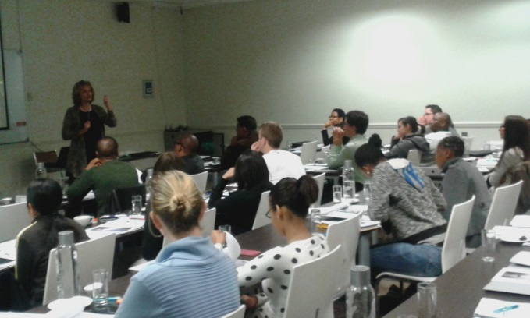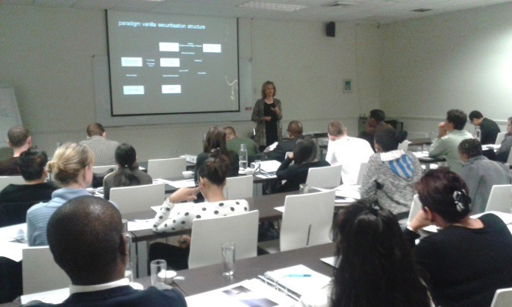
On the first day of the programme, Professor Angela Itzikowitz of Edward Nathan Sonnenberg introduced delegates to securitisation- the advantages of securitisation, the key parties involved , which assets are capable of being securitised ,the establishment of an appropriate SPV and primary regulatory considerations e.g. The Bank’s Act. Jana Kershaw from Ashburton Investments thereafter presented a practical application of the history of securitisation in South Africa.
After lunch on the first day John Doidge explained the role of the trustee in securitisation and Stephen von Schirnding, also from ENS, took delegates through the process of implementing a securitisation.
On the last day of the course, the morning starting with Prof Itzikowitz wrapping up the regulatory considerations, followed by Lourandi Kriel from Fintech using Fintech as a case study to explain the accounting and tax considerations in a securitisation. The day and the course were finished off by Professor Dale Hutchison, a professor at UCT and director at ENS with a detailed explanation of cession out and out and security session. The course was very well received and a number of delegates requested that an advanced course in securitisation be offered next year, possibly in Johannesburg again.

